GENAI
NAME - ANKUR SHARMA
SRN – PES2UG23CS077
When seed=42
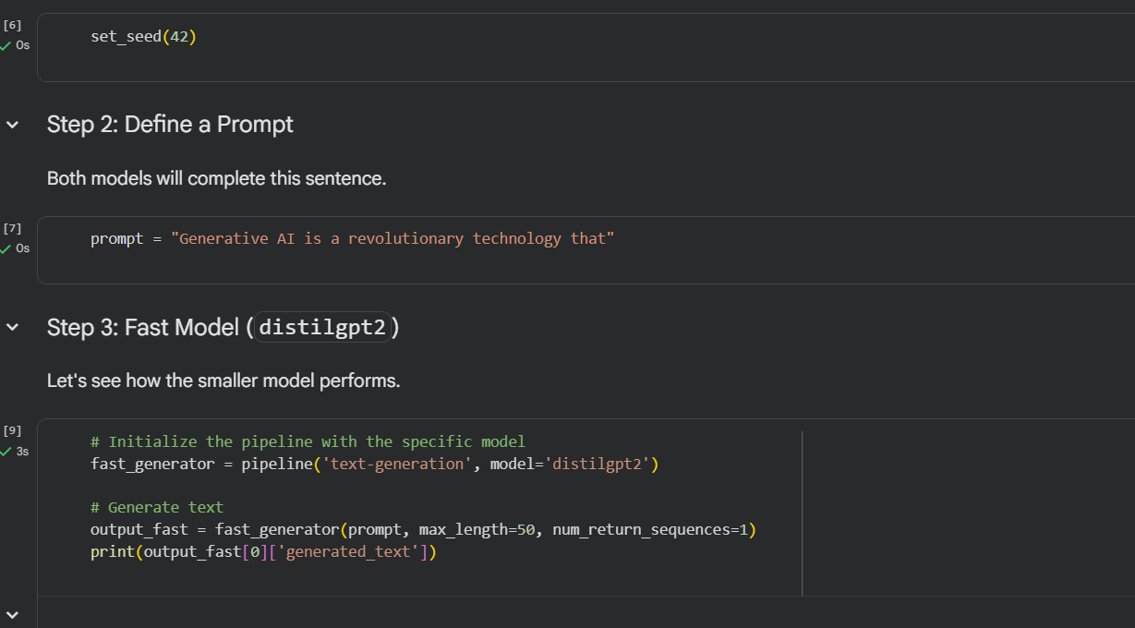
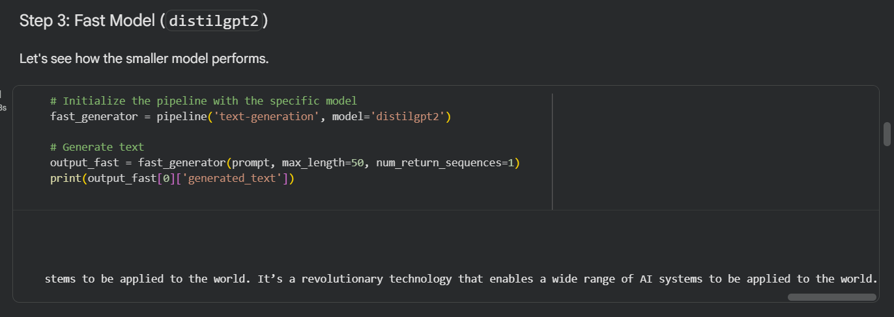
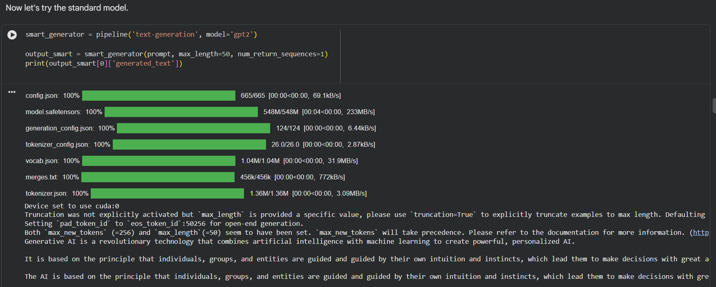

When seed=77
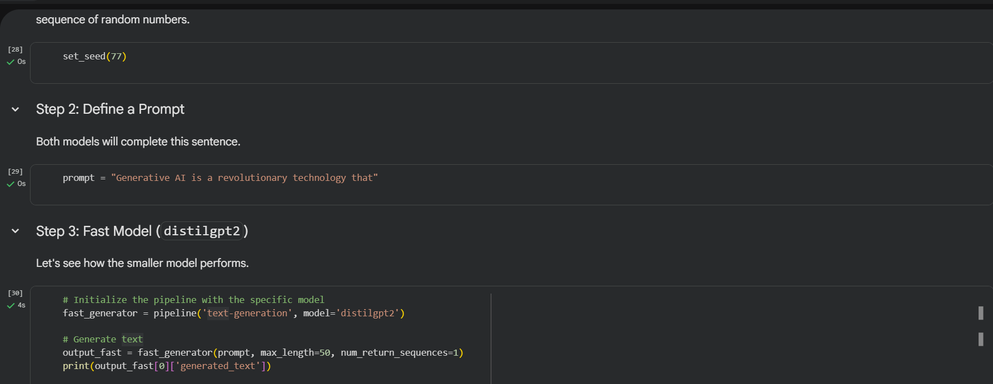
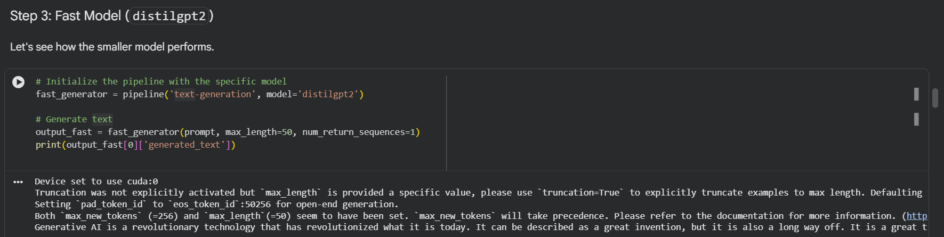
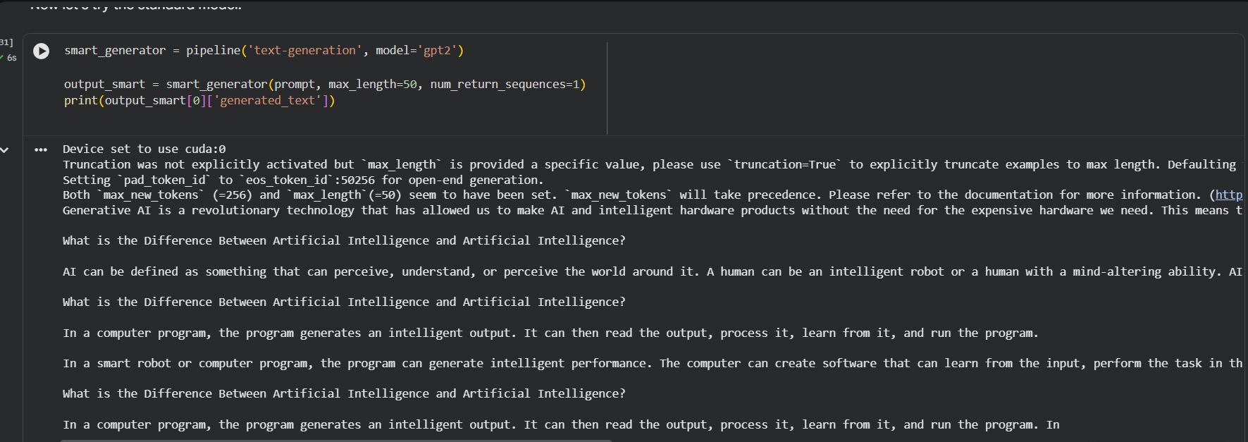

- Difference between the distil and smart(GPT) model:
- Distil model is smallertrans
- Distil model is Faster
- Distil model is requires less memory
- Distil model have less parameter
- Whereas, smart model requires heavy computation and requires large amount of training with very large dataset
A distilled model is a compressed version of a standard model that learns from the teacher model’s outputs to achieve faster inference with minimal loss in performance.
NER:
Named Entity Recognition is the process of identifying and classifying proper names in text into categories such as person, organization, location, and date
- Transformer is a type of deep learning neural network, it works excellent by processing the sequential text GPT2 is one of the model when it is only decoder model, but now a days we have LLM much bigger version of GPT where it have many hidden layers and billions or trillions of parameter.It now have a encoder or decoder
- We access various LLM or GPT model using transformers library is the bridge between the models on Hugging Face and code.

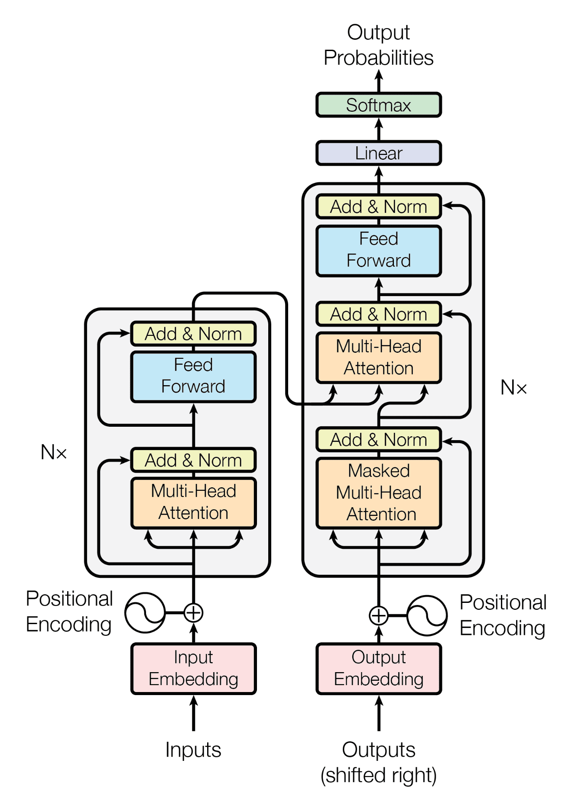

BERT is designed for deep language understanding, while GPT-2 is designed for fluent text generation

• Full form: Bidirectional and Auto-Regressive Transformers
• Architecture: Encoder–Decoder
• Training: Denoising autoencoder (corrupted text → original text)
• Best for: Text generation, summarization, translation

• BART:
A transformer model combining bidirectional encoding and autoregressive decoding, trained as a denoising autoencoder.
• BART vs BERT:
BART supports text generation using an encoder–decoder architecture, while BERT is encoder-only and designed for language understanding.

Hugging Face :
Hugging Face is a popular machine learning platform focused on natural language processing. It provides pre-trained models, datasets, and tools (like Transformers) that make it easy to build, train, and deploy ML models for tasks such as text generation, translation, and sentiment analysis.

